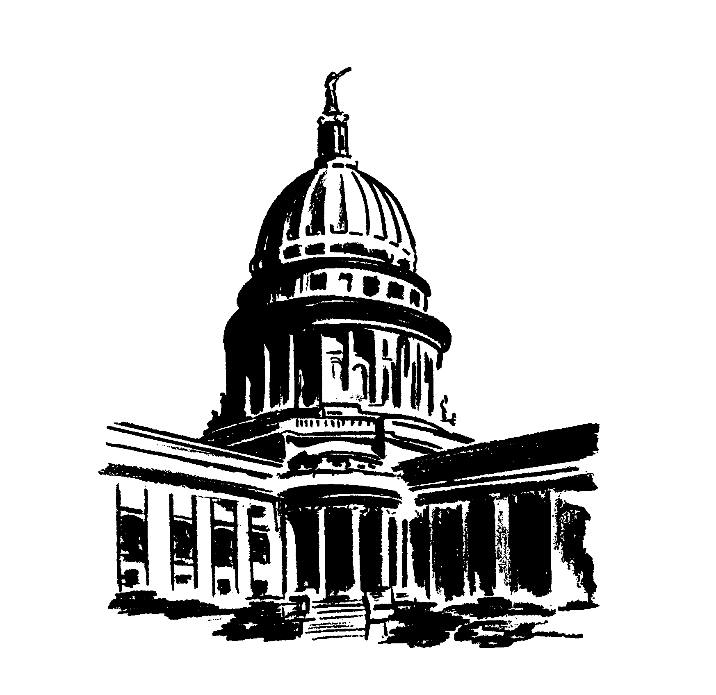
Wisconsin Legislative Council
May 29, 2014

Legislative Council Study Committee on the Review of Criminal Penalties
Chair Rob Hutton, Representative  17785 Marseille Dr.  Brookfield, WI 53045 | Vice-Chair Fred Risser, Senator  100 Wisconsin Ave., Unit 501  Madison, WI 53703
Edward Bailey, Inspector  Milwaukee County Sheriff's Office  821 West State St.  Milwaukee, WI 53233 | Mandela Barnes, Representative  4800 N. Port Washington Rd., Unit 205  Milwaukee, WI 53217
Keith Belzer, Attorney  Devanie Belzer & Schroeder, S.C.  300 N. 2nd St., Suite 200  La Crosse, WI 54601 | Adam Gerol, District Attorney  Ozaukee County Justice Center  1201 South Spring St., P.O. Box 994  Port Washington, WI 53074
Scott Horne, Circuit Court Judge  LaCrosse County, Branch 4  333 Vine St.  La Crosse, WI 54601 | Jill Karofsky, Executive Director  Department of Justice  17 W. Main St.  Madison, WI 53703
Ben Kempinen, Clinical Professor  University of Wisconsin Law School  572 Gately Terrace  Madison, WI 53711 | Adam Neylon, Representative  294 Meadowcreek Ct. #4  Pewaukee, WI 53072
David Reddy, Circuit Court Judge  Walworth County, Branch 4  P.O. Box 1001  Elkhorn, WI 53121 | Daniel Riemer, Representative  3053 S. 39th St.  Milwaukee, WI 53215
John Spiros, Representative  1406 E. Fillmore  Marshfield, WI 54449 | Michael Tobin, Deputy State Public Defender  Wisconsin State Public Defenders Office  315 N. Henry St., 2nd Floor  Madison, WI 53707
Donald Zuidmulder, Circuit Court Judge
Brown County
P.O. Box 23600
Green Bay, WI 54305

STUDY ASSIGNMENT: The Study Committee is directed to review the penalties for misdemeanor and low-level felony offenses. The committee shall: determine whether current misdemeanor or low-level felony penalties are appropriate; whether any crimes should be classified; and whether any offenses are outdated or should be decriminalized.
15 MEMBERS: 5 Representatives; 1 Senator; and 9 Public Members.
LEGISLATIVE COUNCIL STAFF: David Moore and Michael Queensland, Staff Attorneys; and Kelly Mautz, Support Staff.

